CDAC ADMISSION CASE STUDY :
ER DIAGRAM :-
Candidate
|
| (1:M)
|
Preference -----> Center
|
|
v
Course
|
|
v
Center_Courses (Seat Capacity)

Candidate
|
v
Allocation

DATABSE CREATED:
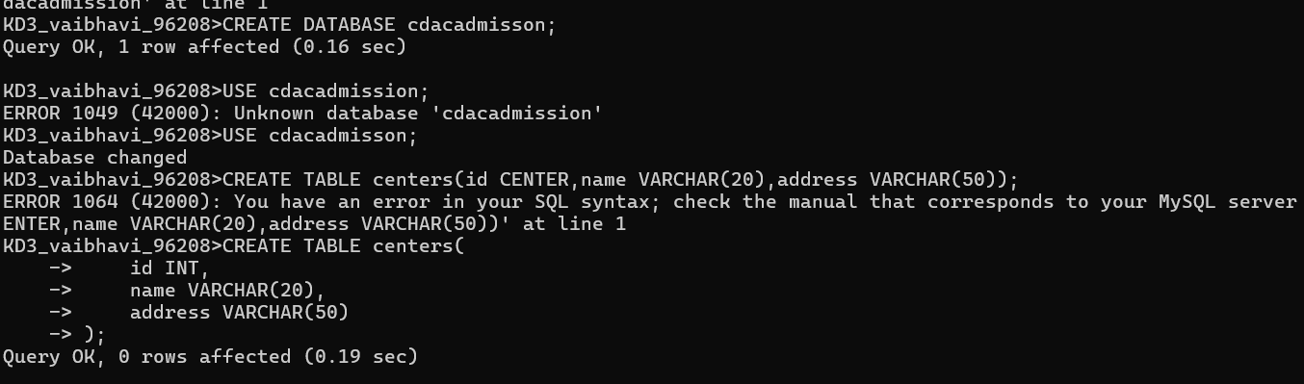
TABLE CREATED:
